The API for InPlay has the same requests, but the response is a little bit different.

Request all tournaments that have in it active InPlay matches.

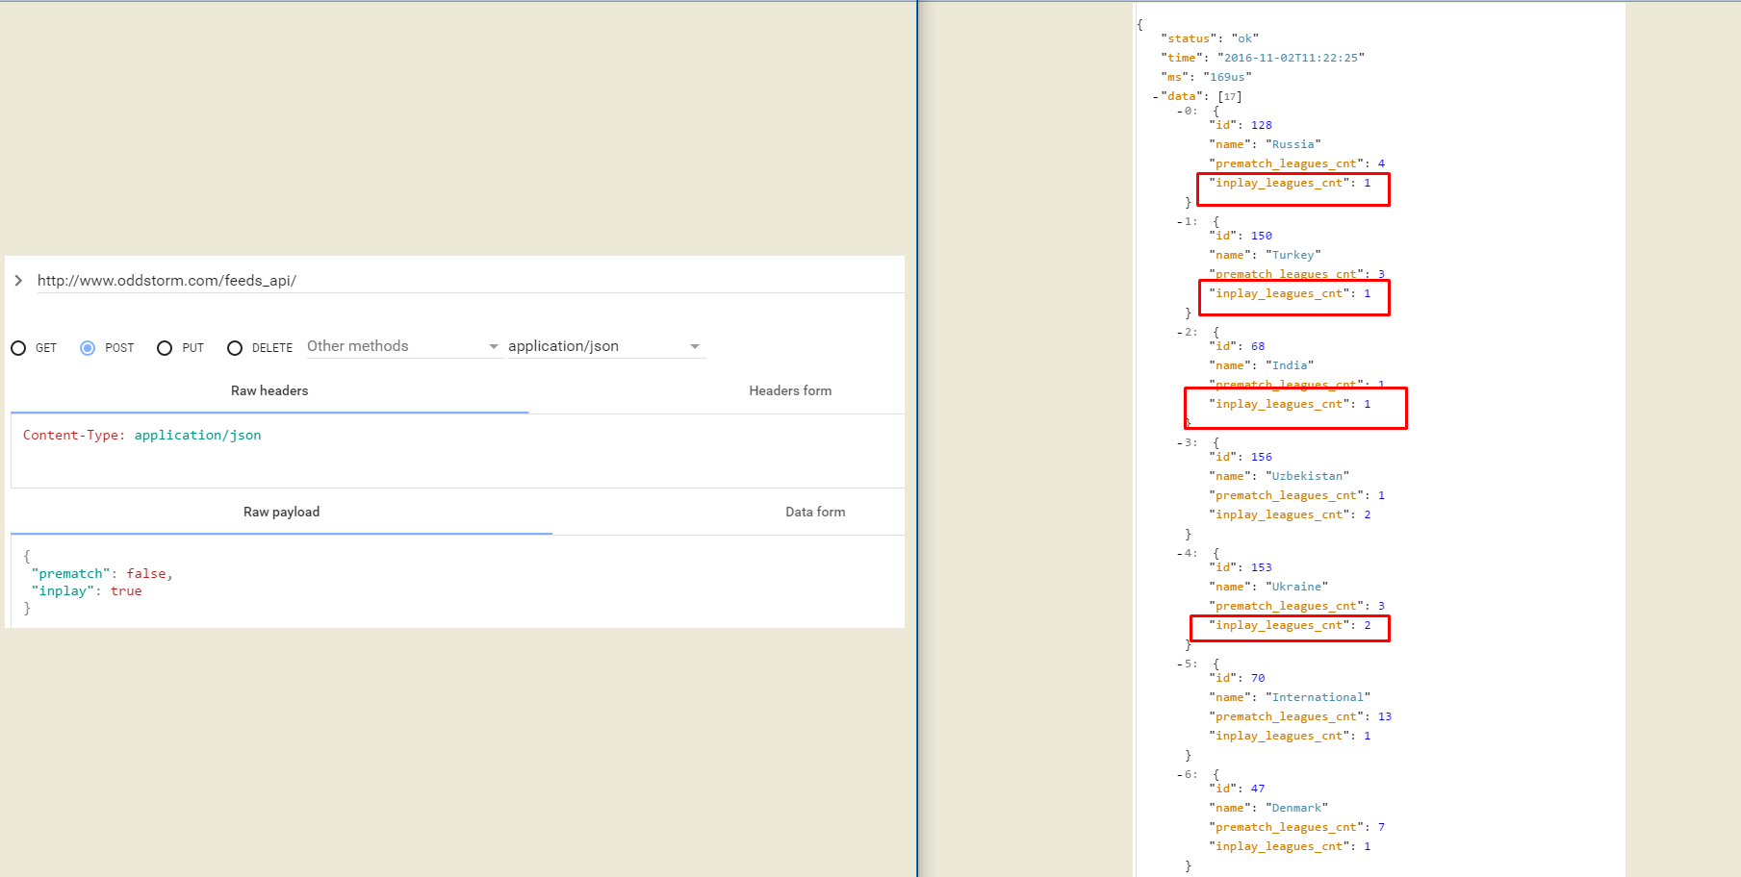

Request all leagues for tournament “153”

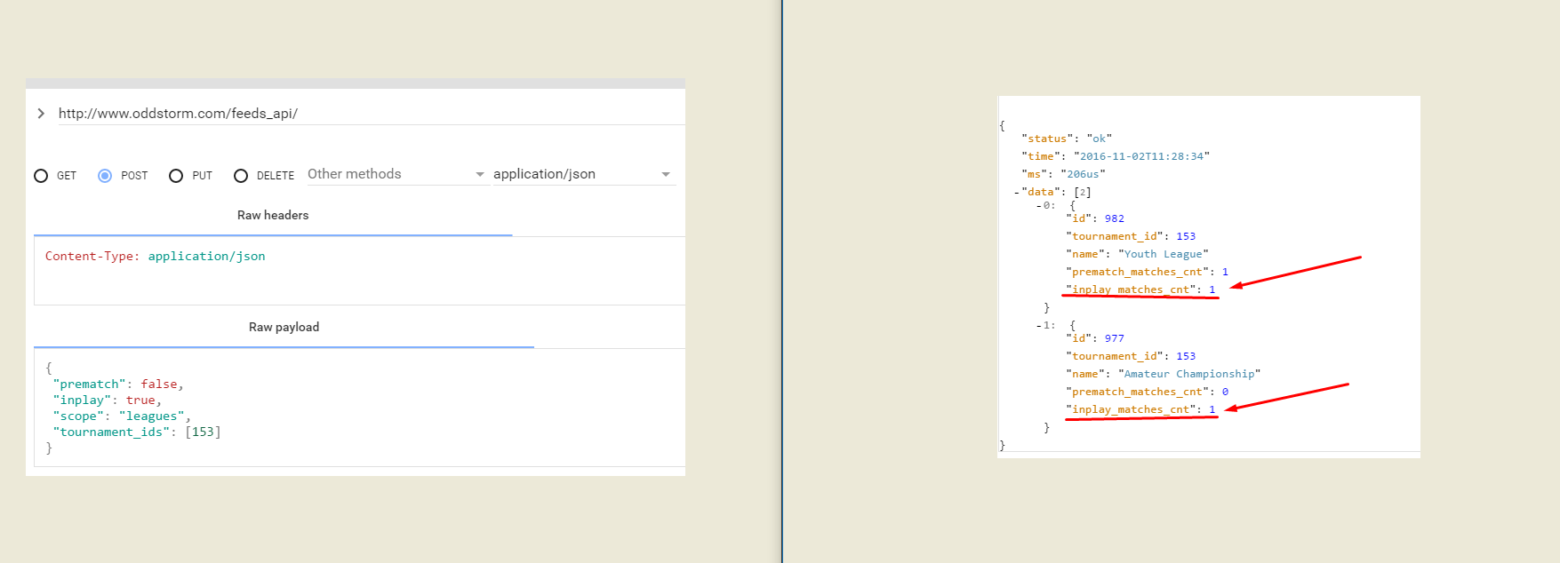

Request all matches for league “982”

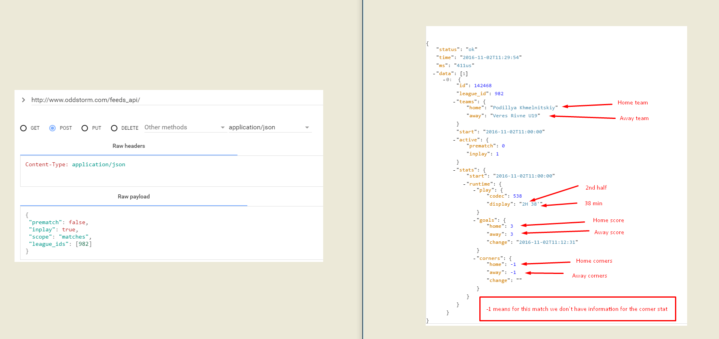

Request all odds for match “137956” from bookmaker “47”

